Evolution Answer Key for Review Packet

- 3
- 3
- 1
- 3
- 4
6.
Ground finch
Eats different food, lives and hunts in different location
Warbler finch
Eats the same food
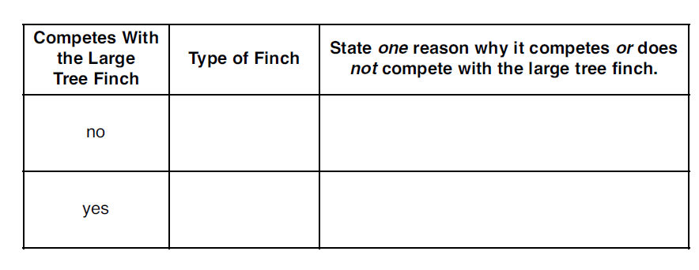
7.3
8.
No effect because they eat different food

- 2
- 1
- 3
- 2
- 3
- 4
- 1
- they eat different sized food or hunt in different locations
- they eat different food or live and hunt in a different location
- spines
- mutations
- animals don’t eat hem because they taste bad and the color will warn predators away
- predators do not know the difference between the poisonous and non-poisonous one so they stay away
- the bats with the strong wings will out compete the weaker bats, the strong bats will survive, and the stronger bats will pass on their genes because they are better adapted and reproduce while the weaker bats die off
- 3
- 2
- mutations are a change in DNA sequences and without the change there is no evolution
- any combination of A T C G that you write that is 9 letters long….. AAATAAGCC
- you can either add a letter, take away a letter or switch the position of 2 letters for this answer……. AATAAGCC

